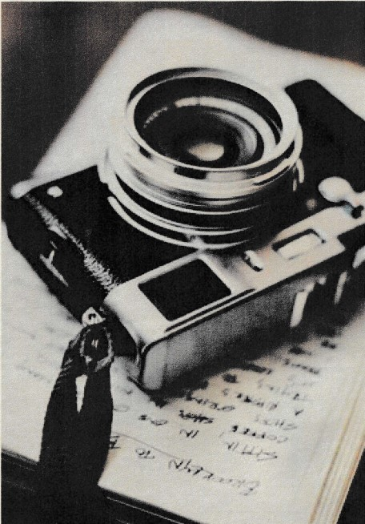
BARLING MAGNA PARISH COUNCIL
PHOTOGRAPHY
COMPETITION 2025
FIRST PRIZE
ln the 16+ category
Awarded to

Callum Weaver

‘To me, to you’

Clerk to the Council

