Hi steph

I have attached a few cycle shelters we use and costs .

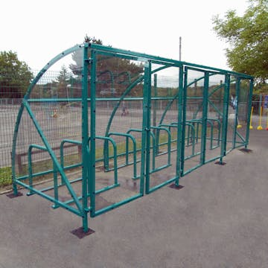
To supply and install above shelter

£4200.00 + vat

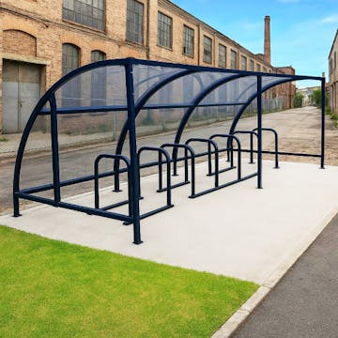
To supply and install above cycle shelter

£ 2900.00 +vat

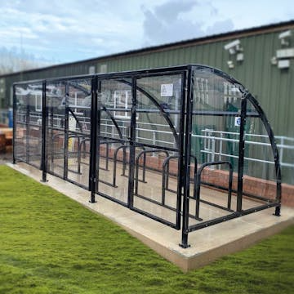
To supply and install the above shelter .

£4500.00 + VAT

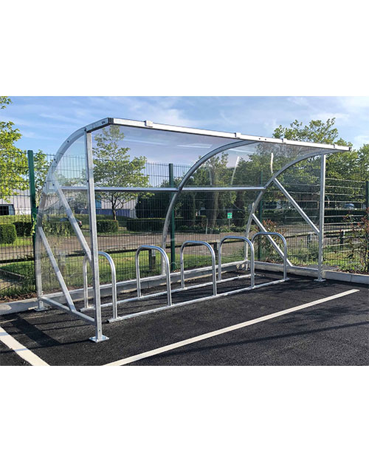
To supply and install the above cycle shelter.

£ 2600.00 + vat

Kind regards

