Barling Magna Parish Council
Parish Clerks Report
Tree management – overhanging Tree adjacent to Council Building.

Purpose of report.
To advise members of concerns regarding the tree situated to the right – hand side of the Council building, which is overhanging the neighbouring garage and adjoining structures, and to seek a decision on the recommended management of the tree.
Background.
A tree located adjacent to the right-hand side of the Council building has grown significantly and now extends over the neighbouring garage and surrounding buildings. Recent inspection of the area, supported by the attached photographs (appendix a & b), highlights the extent of the overgrowth and its proximity to both properties.
The tree and surrounding vegetation are now in direct contact with the neighbouring garage roof and continues to grow towards both buildings.
Observations.
The attached photographs demonstrate that:
- Branches are extending over the neighbouring garage roof,
- Vegetation has become established between the Council building and the neighbouring structure,
- The growth is restricting access between the buildings,
- Continued growth is likely to increase maintenance requirements and may create future issues for both properties if left unmanaged,
- During periods of strong winds or adverse weather there is an increased risk of branches falling onto neighbouring structures.
Whilst there is currently no confirmed structural damage, allowing the tree to continue growing in its current location increases the likelihood of future property damage and associated maintenance costs.
Advice given and Actions already taken.
The Council has been advised that the most appropriate course of action is to remove the tree before more significant issues arise. Preventative action at this stage is considered preferable to undertaking reactive works following damage to either property.
To ensure best value for the Council, the clerk has already requested that the three contractors currently providing quotations for the tree removal works at the Play space and the Wildlife reserve also include the removal of this tree, together with the cutting back of the tree overhanging the pavement at the front of the Village Hall. This will enable members to consider all the required tree works together and determine whether a single contractor should be appointed to undertake the works.
Financial implications.
The cost of the works will be determined following the receipt of quotations and reported to Council in accordance with the Council’s Financial regulations.
Risk assessment.
If no action is taken, the Council should be aware of the potential risks, including:
- Continued encroachment onto the neighbouring property
- Potential damage to roofs, guttering and buildings
- Increased maintenance costs
- Possible liability should falling branches cause damage or injury
- Reduced access for future maintenance between the buildings
Recommendation to Council.
It is recommended that members note the concerns identified within this report and consider the quotations once received for the tree works at the Play space, Wildlife reserve and the Village Hall site as a single programme of maintenance. Subject to being satisfied with the quotations received, members are recommended to appoint a suitably qualified and insured contractor to undertake the removal of the overhanging tree and the associated tree maintenance works, with the Clerk authorised to arrange the works on the Council’s behalf following the resolution of the council and confirmation that no statutory restrictions apply.

Appendix a - 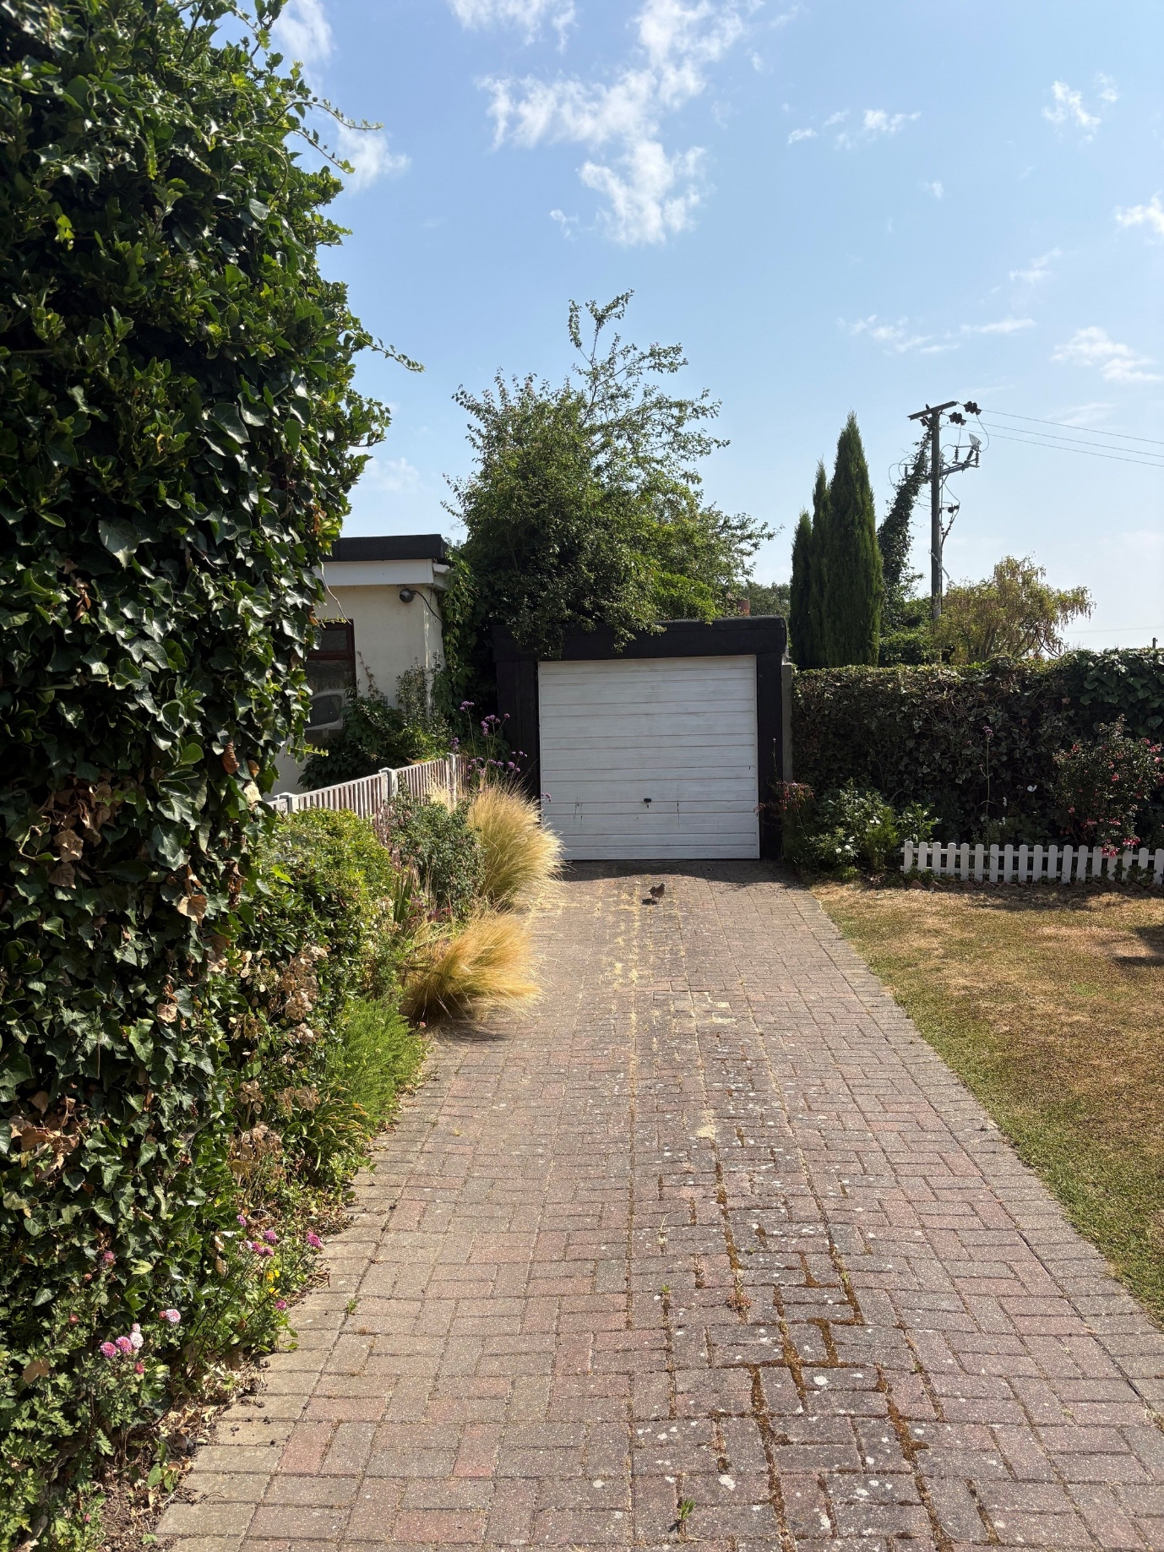

Appendix b - 