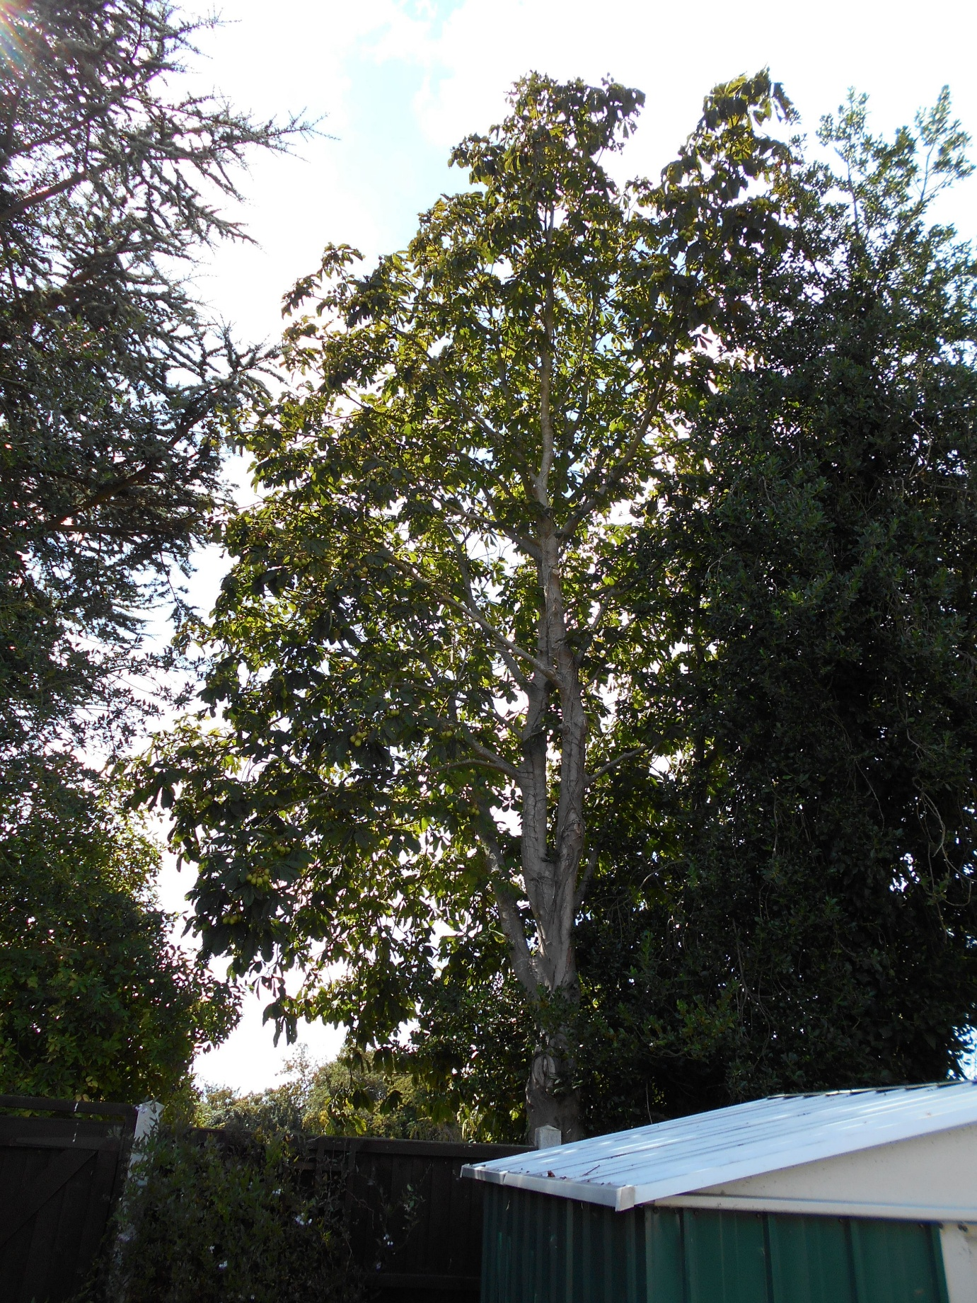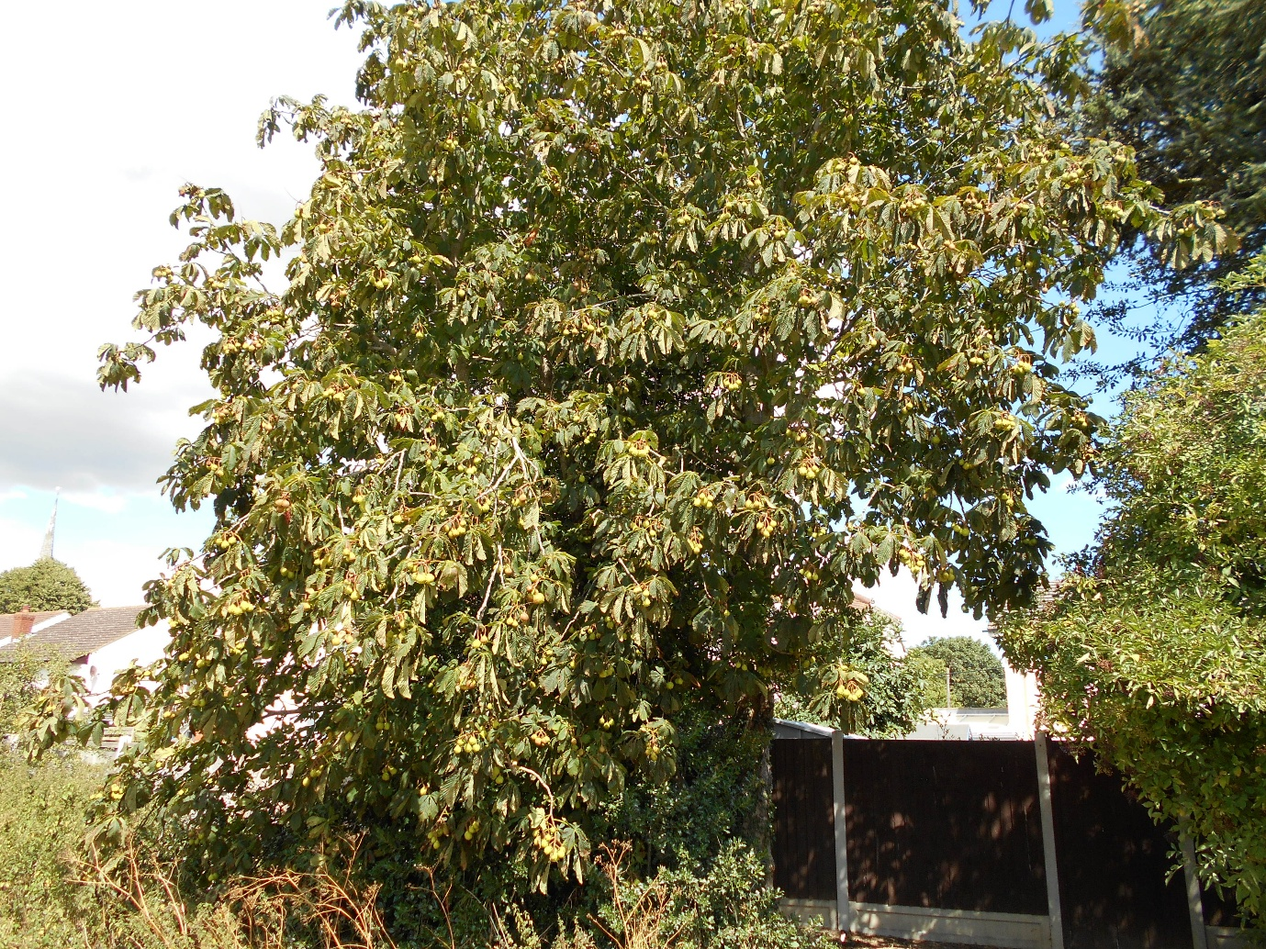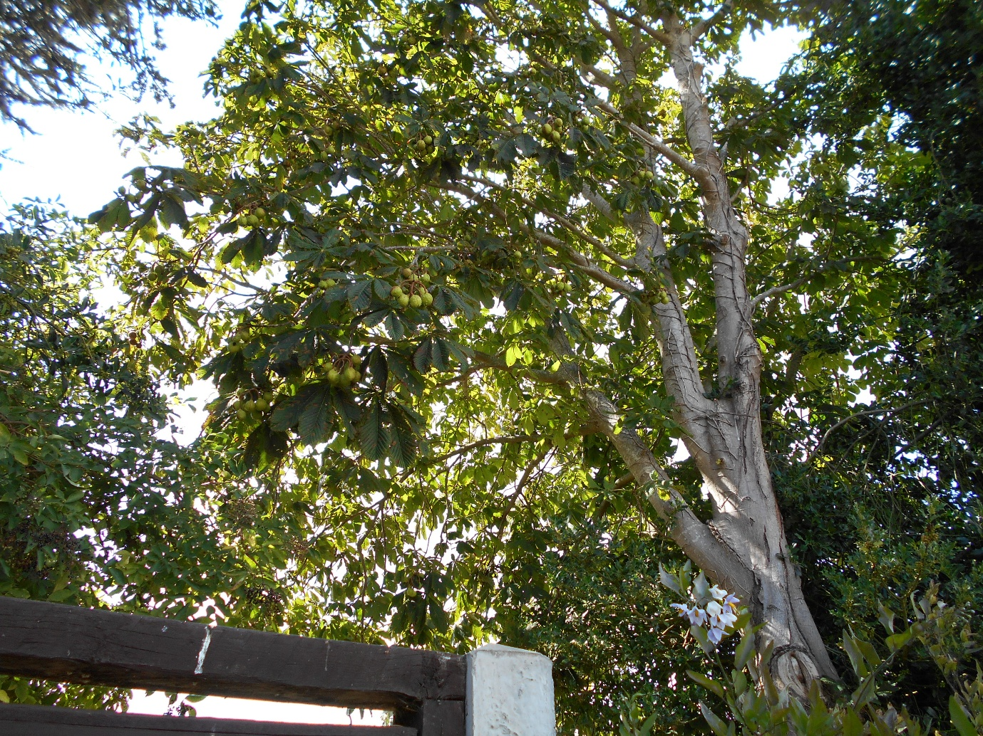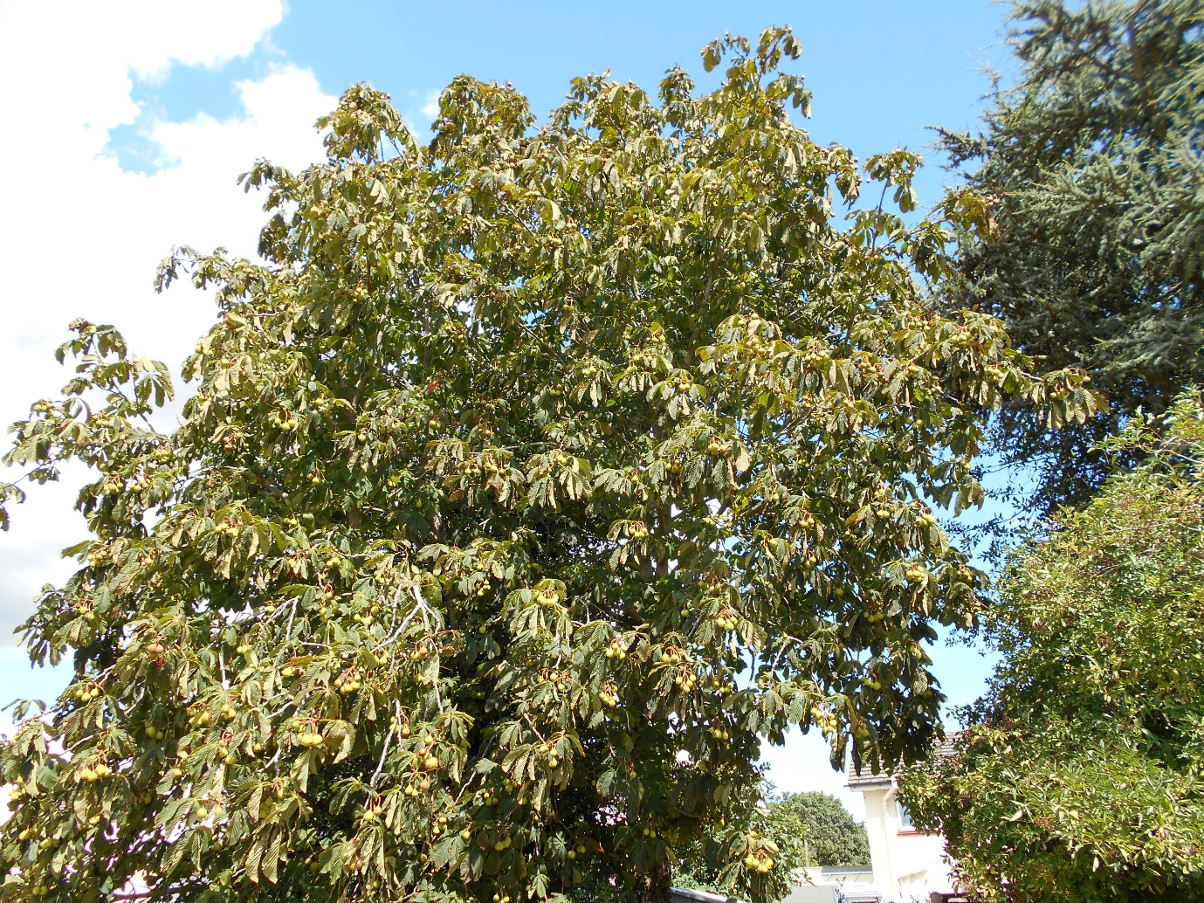

A resident contacted me regarding the cutting back of the tree at the Parry. It is overhanging his garden, and he would like to have it cut back. I have received a quote from Steve regarding this.

